The Stone Laying at the Lichfield Wesleyan Church

There I was a few weeks ago passing through Lichfield with my work and spotted this Methodist church. I normally don't stop but look at the names while passing, however I decided to pull over and have a look and I'm glad I did. I’ve done a bit of research on the place and found an article, have a read below.

“On Wednesday the 12th August 1891 in delightful weather, Tamworth Street was full of colour. A great display of bunting and plenty of people were gathered on the street by the piece of land soon to be the new Wesleyan Church. The Trustees of the connection instructed Mr Thomas Guest of Corporation Street, Birmingham to take up the design at five percent of the outlay. They described the structure in the Lichfield Mercury of 1891 as follows;-

“It will consist of a nave and side aisles. This form of plan is necessitated in consequence of the shape of the land and the difficulty of obtaining light, but the architect has most satisfactory overcome these difficulties. The plan also shows a chancel. The elevation is one of considerable beauty and symmetry, and is designed in the Gothic style of the perpendicular period. It shows a fine entrance consisting of two bold pointed arches, springing from granite columns, surmounted by a tracery balustrade, crowned with octagonal panelled pinnacles. Immediately over the entrance is a flue traceried perpendicular window, flanked by buttresses at the corner of the nave and decorated with triangular panelled pinnacles, the whole front being relieved by carving and general decoration.”

They had great difficulty in the choice of site. It was found that the land in front of the existing chapel (Lombard Street) was inadequate for the proposed new structure. After much delay they found Tamworth Street and three old cottages were removed so work could begin.

Mr Williams of Tamworth was the winning builder at a cost of £2000. For a short time on that Wednesday they set aside some time to lay six memorial stones. Amongst those present were as follows;- Rev P Graham, the Mayor of Lichfield Alderman Haynes and Mrs Haynes, Alderman Shakeshaft, Rev Fish, Councillors Fowler and Hunt, Rev J Bond of London, Mr T Guest (Architect), Rev T Orton and Mr Argyle of Tamworth, Mr and Mrs Holloway &c.

On each stone there was an inscription stating by whom it had been laid. Underneath was placed a bottle containing copies of the local newspapers, the Methodist Recorder, a plan of the circuit, a list of trustees, a programme of the stone laying and several coins.

The Rev Thomas Orton asked the Mayor to step forward and lay the first stone a fitting memory of the day and even more so as he worshipped with them. Rev Orton passed his honour a silver trowel that was inscribed for him. When he had completed his work a cheque for £25 was deposited on the stone.

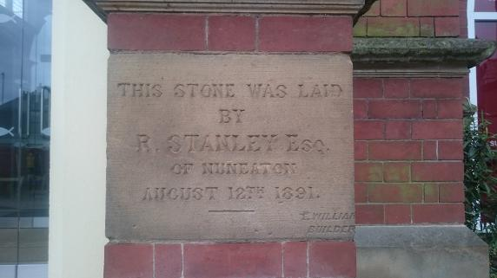The second stone was to be laid by Mr R Stanley of Nuneaton, but he was unable to be present and his place was taken by Mr Argyle who took the silver trowel and laid the stone on the man’s behalf.  Mr Argyle opened a letter from Mr Stanley, inside was a cheque for £25 and he made special mentions to the Mayor and Rev Prebendary Graham from the Church of England uniting with them in that great and important act (applause). He hoped that the building work would be successfully carried out. Reginald dared to say that a Lichfield builder would have liked to have had the contract, but it had been given to a Tamworth man.

The Rev Fish took over the presentations and passed the next trowel to Mr Frisby of Leicester who laid his stone and donated £10. Next was Mr Ockey of Birmingham an old worshipper in the Wesleyan Chapel who passed the silver trowel to Mr W North of Lichfield and then onto Mr J H Waring the secretary whose efforts had contributed in a great measure to the success which had thus far attended the undertaking. Mr Holloway then stepped forward and passed the trowel to Mr W Taylor, who laid the stone on behalf of the teachers and scholars of the Sunday School. A collection was made from those present and all had an opportunity to lay 'bricks' for a small donation.

The evening meeting was held in the Guildhall and a large number including many visitors from a distance sat down to tea. The meeting was led by Mr Sadler steward of the Tamworth Circuit. The Chairman opened with a joke that he thought the chapel when complete would compete with the fine Cathedral to which came plenty of laughter, he quipped that the site was good and the building was one of beauty. The Secretary also read out the long list of subscriptions which amounted to £1148 6s 8d (applause) leaving a slight deficit on the £2000 building costs. It was such a shame Reginald couldn't have been present and I wonder why. He was a wanted man when it came to Churches and the Methodist denomination he had devoted his past time and money to.

An extract from the website [www.reginaldstanley.com/lichfield-wesleyan-church.php](http://www.reginaldstanley.com/lichfield-wesleyan-church.php)

----------- x ------------

2014 was the 100 year anniversary of Reginald Stanley's death and this website has been produced in memory of him. Reginald's journey to the author’s home town of Nuneaton came via Hayle, Glasgow, America's wild west and a gold mining town formed by Reginald and three lucky prospectors which was eventually called Helena. He made his fortune and headed back to England via Leicester eventually finding a place to call home in Nuneaton.

His legacy was left behind in the form of bricks. Many of Nuneaton buildings were made by Reginald's business Stanley Brothers. He owned brickyards, collieries, and an engineering firm, all have now disappeared and covered by many houses. If you live in Stockingford there is a good chance the land you are on now was once something to do with the company. If you live in the UK the chances are the bricks in your house were from Nuneaton, Stanley Brothers reportedly had 4000 customers.

A further extract from [www.reginaldstanley.com/lichfield-wesleyan-church.php](http://www.reginaldstanley.com/lichfield-wesleyan-church.php) explaining the website author’s connection to Reginald Stanley.

February 2023